Predicting Influenza A Positive Test Rates in North Carolina Public Health Epidemiologist Facilities Using Wastewater Surveillance Data
Brianna Gamble, Katey Le, Rosalba Barojas Chavarria, Unison Park
bmgamble24@gmail.com, rosalbachavarria18@gmail.com, parkunison4@gmail.com, le.kateyt@gmail.com

Abstract
Background: The 2024-2025 influenza season in North Carolina reached high-severity, underscoring the need for timely population-level surveillance tools, including wastewater surveillance, whose predictive utility for influenza remains understudied.
Methods: This study evaluated whether influenza A viral RNA in wastewater from the North Carolina Wastewater Monitoring Network could predict laboratory-confirmed influenza A positive test rates reported by Public Health Epidemiologist facilities. A retrospective time-series analysis of statewide surveillance data (September 2024 to September 2025) used aggregated and log-transformed weekly wastewater and clinical data, with lagged viral load in a GARCH-X time-series model to generate 1–4 week forecasts.
Results: Wastewater influenza A viral RNA strongly correlated with clinical influenza activity (r = 0.89), peaking at a one-week lead (r = 0.91). Short-term GARCH-X forecasts performed best at 1-2 weeks.
Conclusion: Influenza A viral RNA in wastewater modestly preceded clinical influenza activity, supporting wastewater surveillance as a timely early-warning indicator for statewide influenza monitoring and response.
Key words:
Wastewater surveillance, wastewater-based epidemiology, Influenza A, Garch-X model, time-series forecasting, early warning systems

- Background
The 2024-2025 United States influenza season was characterized as high severity, a distinction not used since the 2017-2018 season, with cumulative influenza-associated hospitalizations reaching 128.1 per 100,000, the highest rate since 2010-2011 (CDC, 2025). North Carolina experienced “High” and “Very High” activity categories on the CDC (2024) influenza-like illness map for 11 consecutive weeks (December 28, 2024 - March 8, 2025). Additionally, the North Carolina Department of Health and Human Services (NC DHHS) reported more than 500 influenza-associated deaths, the highest since 2009 (2025). Wastewater surveillance has emerged as a valuable tool, proven during the COVID-19 pandemic, where the detection of SARS-CoV-2 RNA in wastewater provided an early warning of clinical case surges (Landstrom et al., 2022). However, its application to influenza remains underdeveloped, with most studies emphasizing the technical feasibility of viral detection rather than predictive performance (Dlamini et al., 2024). To address this, we analyzed 2024-2025 data from the North Carolina Wastewater Monitoring Network (NCWMN) using a GARCH-X modeling approach to evaluate whether wastewater influenza A RNA concentrations can predict weekly laboratory-confirmed influenza-positive test rates across Public Health Epidemiologist (PHE) facilities in North Carolina (NC DHHS, n.d.).
- Methods: Data and Analysis
We conducted a retrospective time-series analysis using publicly available data from the NC DHHS Data Behind the Dashboards portal. Clinical influenza surveillance data were obtained from the dataset titled “COVID-19/Influenza Test Positive in PHE Facilities,” which reports weekly counts of positive influenza tests from PHE facilities across NC. At the time of data download, this data spanned from September 14, 2024 through September 6, 2025. Wastewater surveillance data were obtained from the dataset titled “Wastewater Monitoring (FLU A),” which reports weekly influenza A viral RNA concentrations measured across 31 participating wastewater treatment sites in NC. Site-level weekly influenza A viral gene copies per person were aggregated by epidemiological week using the mean across all participating sites. Clinical influenza test data were similarly population-weighted and aligned to epidemiological weeks defined as Sunday through Saturday. The predictor variable was the weekly average Influenza A viral gene load in wastewater. The outcome variable was the weekly influenza positive test rate, calculated as the weekly count of positive tests divided by the total state population for the respective years and scaled to a rate per 100,000 persons.
All analyses were conducted in R (Version 2025.05.0+496). Both time-series (wastewater and the influenza rate) were log-transformed. Influenza B was excluded from analysis due to weak correlation with the test rate (Pearson’s r=-0.03), while influenza A was retained (Pearson’s r = 0.98). The ACF package in R confirmed significant autocorrelation, supporting forecasting. Figure 1(c) depicts the results, up until lag 6, both the log influenza positive test rate and log weekly wastewater viral load indicate significant autocorrelation, beyond what would be expected from pure random noise (Jones, 2010).
GARCH-X Model
To model and forecast influenza positive test rates, we employed a generalized autoregressive conditional heteroskedasticity model with an exogenous variable (GARCH-A) using the rugarch package in R. An initial ARIMA model was explored, in which indication of potential heteroskedastic residuals from insufficient coverage within forecast confidence intervals were revealed. Consequently, a GARCH-based approach was selected to explicitly model time-varying volatility in the error structure. The GARCH-X model allows for the inclusion of an exogenous variable, allowing us to also consider lagged wastewater weekly viral load (Vorsah et al., 2025). To define the train and test segments, we selected various time points within the data where there were a smooth increase and decrease, allowing us to forecast the positive tests most accurately. An index week variable was created to more easily define the train end. The selected train end weeks were 16, 25, 29, 40, and 45, corresponding to 12/28/2024, 03/01/2025, 03/29/2025, 06/14/2025, and 07/19/2025 respectively. The test segments ranged from 1 to 4 weeks of forecast using lagged wastewater data.
- Results
Descriptive analyses were conducted for both the weekly influenza A positive test rate and the average weekly influenza A viral load in wastewater. The mean influenza A positive test rate was 7.34% (median = 0.75; Q1 = 0.31; max = 52.60) and the mean average viral load of influenza A was 4.4e6 (median = 1.04e6; Q3 = 4.05e6; max = 3.06e7). Both distributions were highly right-skewed. To address skewness and stabilize variance, both variables were log-transformed. The mean log-transformed Influenza A positive test rate was 0.16 (median =-0.12; IQR = -0.50 to 0.95) while the mean log-transformed average viral load was 6.24 (median = 6.02).
Temporal trend analysis demonstrated that Influenza A viral gene copies detected in wastewater closely mirrored trends in reported influenza-positive cases in NC from September 2024 through September 2025 (Figure 1(a)). Both series exhibited clear seasonal patterns, with peaks occurring between January and March 2025, reflecting the height of the influenza season. After log transformation, the Pearson correlation between Influenza A weekly viral load and positive influenza cases were r = 0.89, indicating a strong positive association.

Figure 1. (a) Temporal trends of influenza A viral gene copies in wastewater (indicated in blue) and positive influenza cases (indicated in red) in North Carolina. Both series were log-transformed using the logarithm for comparability. (b) Pearson correlation coefficient between wastewater weekly viral load and influenza positive test at 1-,2- and 3-week lags. (c) Log-transformed autocorrelation of the influenza rate and wastewater weekly viral load. Bars outside of the blue dotted bounds indicate significant autocorrelation.
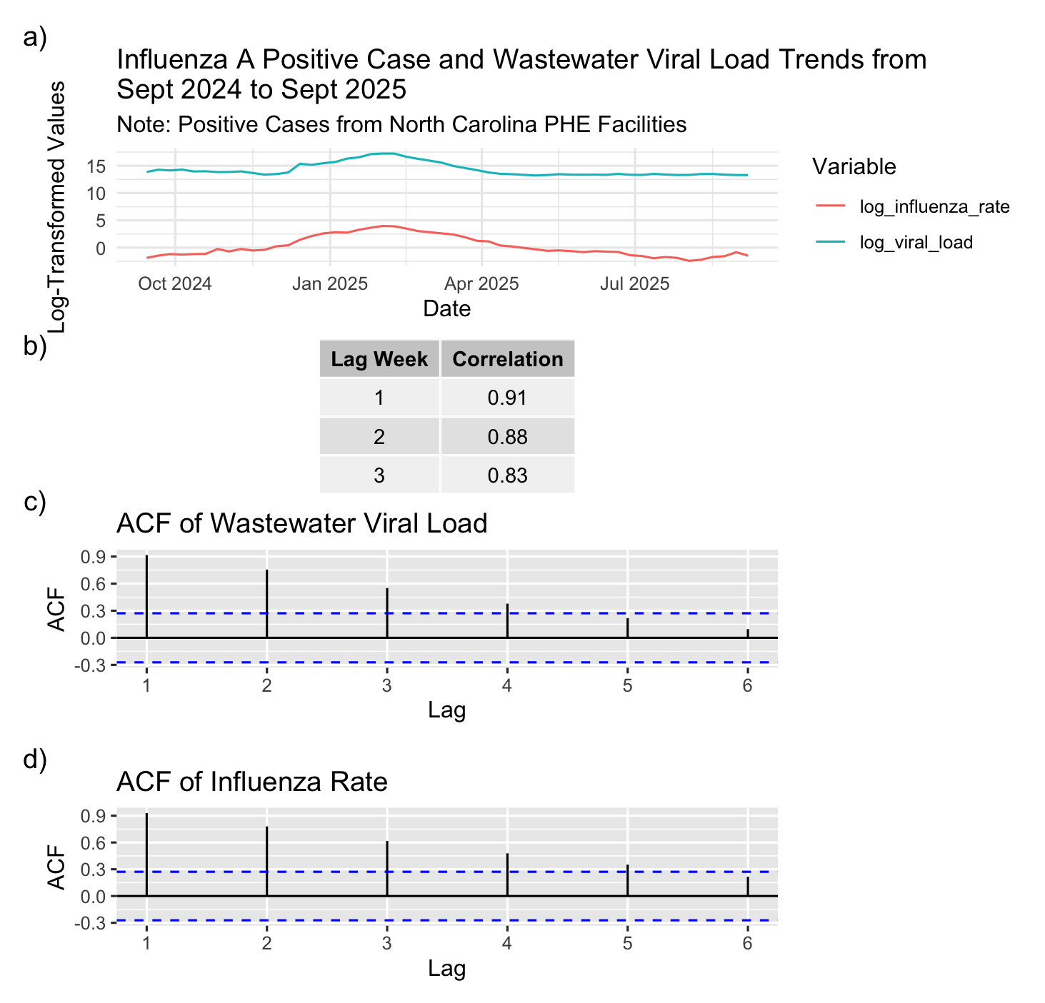
Table 1. GARCH-X Model Results for Index Weeks 16, 25, 29, 40, and 45 as Model Test Endpoints.
Train end week | Actual week | Predicted week | Predicted date | Lag (weeks) | Wastewater Viral Load | Actual rate | Predicted rate | Lower 95% CI | Upper 95% CI
16 | 2024-12-28 | 17 | 2025-01-04 | 1 | 6553074.073 | 16.8 | 17.8 | 5.298 | 44.53
16 | 2024-12-28 | 18 | 2025-01-11 | 2 | 12081622.509 | 15.683 | 16.387 | 4.006 | 45.613
16 | 2024-12-28 | 19 | 2025-01-18 | 3 | 15404521.108 | 26.298 | 39.191 | 9.472 | 109.73
16 | 2024-12-28 | 20 | 2025-01-25 | 4 | 27159974.261 | 38.308 | 0.898 | 0.323 | 2.008
25 | 2025-03-01 | 26 | 2025-03-08 | 1 | 5785709.992 | 13.685 | 15.103 | 7.344 | 27.697
25 | 2025-03-01 | 27 | 2025-03-15 | 2 | 3159884.612 | 11.173 | 15.811 | 6.637 | 32.051
25 | 2025-03-01 | 28 | 2025-03-22 | 3 | 2149676.82 | 6.734 | 14.46 | 5.771 | 30.295
25 | 2025-03-01 | 29 | 2025-03-29 | 4 | 1463503.305 | 3.529 | 26.033 | 11.182 | 51.979
29 | 2025-03-29 | 30 | 2025-04-05 | 1 | 961289.975 | 3.142 | 2.966 | 1.574 | 5.106
29 | 2025-03-29 | 31 | 2025-04-12 | 2 | 744065.709 | 1.477 | 2.835 | 1.326 | 5.343
29 | 2025-03-29 | 32 | 2025-04-19 | 3 | 695863.095 | 1.233 | 2.493 | 1.057 | 5.022
29 | 2025-03-29 | 33 | 2025-04-26 | 4 | 613958.637 | 0.954 | 4.83 | 1.893 | 10.238
40 | 2025-06-14 | 41 | 2025-06-21 | 1 | 736057.509 | 0.45 | 0.467 | 0.348 | 0.613
40 | 2025-06-14 | 42 | 2025-06-28 | 2 | 626252.256 | 0.252 | 0.477 | 0.33 | 0.665
40 | 2025-06-14 | 43 | 2025-07-05 | 3 | 608044.831 | 0.216 | 0.449 | 0.344 | 0.577
40 | 2025-06-14 | 44 | 2025-07-12 | 4 | 730283.989 | 0.144 | 0.38 | 0.302 | 0.472
45 | 2025-07-19 | 46 | 2025-07-26 | 1 | 599393.372 | 0.153 | 0.175 | 0.09 | 0.309
45 | 2025-07-19 | 47 | 2025-08-02 | 2 | 609721.344 | 0.09 | 0.198 | 0.106 | 0.34
45 | 2025-07-19 | 48 | 2025-08-09 | 3 | 713828.468 | 0.108 | 0.194 | 0.105 | 0.33
45 | 2025-07-19 | 49 | 2025-08-16 | 4 | 726327.768 | 0.18 | 0.176 | 0.093 | 0.304
*Wastewater is measured as the weekly average viral gene load for Influenza A.
Lagged correlation analysis further suggested that weekly wastewater viral concentrations modestly preceded increases in positive cases. The strongest correlation was observed at a one-week lag (r = 0.91). Correlations declined gradually with longer lags: r = 0.88 at two weeks, and r=0.83 at three weeks (Figure 1(b)). These results indicate that influenza A weekly viral concentrations in wastewater strongly mirror and may lead trends in positive cases, supporting the potential utility of wastewater surveillance as an early warning indicator of statewide influenza viral activity.
The GARCH-X model demonstrated high accuracy during periods of low transmission and inter-seasonal plateaus (weeks 40 and 45), where predictions consistently aligned with actual positive test rates within the 95% confidence intervals (index week 40, 1-week lag: predicted 0.47; 95% CI: 0.35-0.61) (Table 1). In contrast, during periods of higher influenza activity, the model captured overall trends but exhibited wider confidence intervals at longer lags, reflecting increased volatility, (index week 16, 3-week lag produced 95% CI: 9.47-109.73). Model performance during these high-volatility intervals varied by forecast horizon; while short-term forecasts (1-2 weeks) remained robust, accuracy diminished at 4-weeks lags. These findings indicate that while the model is effective for short-term forecasting and baseline monitoring, its predictive reliability weakens at 4-week horizons during rapid transitional phases.
- Discussion
This study demonstrates that wastewater influenza A viral RNA concentrations closely mirror and modestly precede positive influenza tests reported by PHE facilities in NC during the 2024-2025 influenza season. The strong temporal alignment observed between weekly wastewater viral load and clinical influenza positivity rates is consistent with findings from recent national and international investigations. Wolf et al. (2023) reported that wastewater influenza RNA reliably tracks community influenza activity and can rise 7-14 days before increases detected by clinical surveillance. As emphasized in the literature, clinical surveillance is only the “tip of the iceberg,” whereas wastewater surveillance can capture infections that are not recorded or tracked (Kilaru et al., 2023). Additional studies further support this relationship: Maida et al. (2024) found that influenza A viral RNA measured through wastewater-based epidemiology provides a consistent and reliable population-level assessment of influenza activity. Collectively, these findings reinforce the growing evidence that wastewater monitoring is an effective tool for monitoring influenza trends and identifying increases in transmission earlier than clinical data alone.
Importantly, prior surveillance efforts in NC highlight the need for continued evaluation of wastewater-based approaches. During the 2022-2023 influenza season, the peak in ED cases preceded the peak observed in wastewater surveillance, underscoring that the temporal relationship between these surveillance systems may vary by season and context. Therefore, studies such as the present analysis contribute valuable evidence of the utility of wastewater surveillance in monitoring influenza.
The predictive value of wastewater surveillance is further supported by recent public health applications. A 2024 CDC MMWR report documented successful detection of influenza A viral RNA including highly pathogenic H5 subtypes in wastewater monitoring can supplement and enhance traditional influenza reporting systems (Louis et al., 2024). Because wastewater surveillance captures viral shedding from both symptomatic and asymptomatic individuals, it provides a broader and more stable signal of community transmission compared to clinical testing alone. Consistent with this evidence, our findings support the use of wastewater influenza A RNA concentrations as a practical and timely early-warning tool that can strengthen public health preparedness, guide resource planning, and improve situational awareness during high-severity influenza seasons (Viviani, 2025). As previously mentioned, our findings suggest that our model is effective for short-term forecasting with decreased accuracy seen in 4-week lag forecasts, and wider confidence intervals seen during periods of high influenza positive test rate volatility. Wastewater viral load was added to Table 1 to identify potential patterns explaining these findings, however, the viral load trend closely mirrors that of our actual influenza positive test rate.
Beyond its epidemiologic value, wastewater surveillance also offers substantial cost advantages. Prior research has highlighted that this approach is a cost-effective method for providing population-level representation (Kilaru et al., 2023). A U.S. academic lab estimated that analyzing a single wastewater sample representing an entire catchment area cost roughly 300 dollars, while an individual Polymerase Chain Reaction test has a median list price around 148 dollars (Safford, Shapiro, & Bischel, 2022). Therefore, generating community-level data via wastewater sampling is significantly more economical than the thousands of individual clinical tests required to generate comparable data.
Several limitations should be considered when interpreting these findings. The relatively small sample size (52 weekly observations) generated multiple modeling warnings in RStudio, as prior literature recommends that the sample size be no less than 700 for robust time-series analysis (Ng & Lam, 2006). This constraint limited our ability to explore seasonality or conduct long-term monthly forecasts. Additionally, wastewater surveillance cannot capture viral shedding from every single person, as not everyone is connected to a sewer network (Kilaru et al., 2023). Despite these limitations, the consistency between wastewater and clinical signals observed in this study underscores the value of wastewater surveillance even within constrained datasets.
Future research should build on these findings by investigating influenza-positive tests across multiple seasons to more accurately assess seasonality and temporal variability. Expanding analyses to include advanced forecasting approaches, such as dynamic linear models and machine learning-based techniques, may improve predictive performance. Incorporating additional covariates, including vaccination uptake, demographics and healthcare utilization patterns, could refine model accuracy and enhance interpretability. Collectively, these improvements would strengthen the role of wastewater surveillance as a complementary, cost-effective component of influenza monitoring systems, supporting timely and informed public health decision-making.

References
Centers for Disease Control and Prevention. (2025, June 26). 2024-25 influenza season update and
seasonal influenza vaccine recommendations for the 2025-26 U.S. influenza season
[Presentation slides]. https://www.cdc.gov/acip/downloads/slides-2025-06-25-26/04-dugan- influenza-508.pdf
Centers for Disease Control and Prevention. (2024, September 6). Weekly US Map: Influenza
Summary Update. https://www.cdc.gov/fluview/surveillance/usmap.html
Dlamini, M., Msolo, L., Ehi Ebomah, K., Nontongana, N., & Okoh, A. I. (2024). A systematic review
on the incidence of influenza viruses in wastewater matrices: Implications for public health. PLOS ONE, 19(4), e0291900. https://doi.org/10.1371/journal.pone.0291900
Jones, S. (2010, January 20). R, ACF and statistical significance [Web page]. Square Goldfish.
https://www.squaregoldfish.co.uk/programming/r_acf_significance.md
Kilaru, P., Hill, D., Anderson, K., Collins, M. B., Green, H., Kmush, B. L., & Larsen, D. A. (2023).
Wastewater surveillance for infectious disease: A systematic review. American Journal of Epidemiology, 192(2), 305–322. https://doi.org/10.1093/aje/kwac175
Landstrom, M., Braun, E., Larson, E., Miller, M., & Holm, G. H. (2022). Efficacy of SARS-CoV-2
wastewater surveillance for detection of COVID-19 at a residential private college. FEMS
microbes, 3, xtac008. https://doi.org/10.1093/femsmc/xtac008
Louis, S., Mark-Carew, M., Biggerstaff, M., et al. (2024). Wastewater surveillance for influenza A virus and H5 subtype during the highly pathogenic avian influenza A(H5N1) outbreak — United States, May 12–July 13, 2024. MMWR, 73(37), 804–809.
https://www.cdc.gov/mmwr/volumes/73/wr/mm7337a1.htm
Maida, C. M., et al. (2024). Detection of influenza virus in urban wastewater during seasonal activity.
International Journal of Environmental Research and Public Health, 21(4), 1234.
https://www.ncbi.nlm.nih.gov/pmc/articles/PMC11302137/
Ng, H. S. R., & Lam, K. P. (2006, October). How does sample size affect GARCH models? In
Proceedings of the 9th Joint International Conference on Information Sciences (JCIS-06). Atlantis Press. https://doi.org/10.2991/jcis.2006.139
North Carolina Department of Health and Human Services. (n.d.). Data Behind the Dashboards —
NC COVID-19 [Data portal page]. Retrieved December 9, 2025, from https://covid19.ncdhhs.gov/dashboard/data-behind-dashboards
North Carolina Department of Health and Human Services. (2025, April 9). More Than 500 Flu Deaths in North Carolina [Pressrelease].
https://www.ncdhhs.gov/news/press-releases/2025/04/09/more-500-flu-deaths-north- carolina
Safford, H. R., Shapiro, K., & Bischel, H. N. (2022). Wastewater analysis can be a powerful public
health tool—if it’s done sensibly. Proceedings of the National Academy of Sciences of the United States of America, 119(6), e2119600119. https://doi.org/10.1073/pnas.2119600119
Viviani, L. (2025). Wastewater-based epidemiology of influenza viruses: A systematic review.
Link (PDF):
https://air.unimi.it/retrieve/73e44720-6de5-4bf5-8171-93fa4a8fcbe1/2025_Wastewater-based%20epidemiology%20of%20influenza%20viruses%20a%20systematic%20review.pdf
Vorsah, R., Quaicoe, O., Asiseh, F., & Ng’ombe, J. N. (2025). Modelling maize price volatility in sub- Saharan Africa: a GARCH-X approach. Applied Economics Letters, 1–9. https://doi.org/10.1080/13504851.2025.2501278
Wolfe, M. K., Wigginton, K. R., & Boehm, A. B. (2023). Wastewater-based detection of influenza
activity before clinical reporting. Nature Communications, 14, 1234.
https://doi.org/10.1101/2022.02.15.22271027

